**WooCommerce Custom Fields Plugin**

**Installation and Usage Instructions**

1. Download the plugin zip file and extract it to your WordPress plugins directory.
2. Activate the plugin in your WordPress admin dashboard.

**Plugin URL: -**

**Drive link: -**

**GitHub Link: -**

**Plugin Overview: -**

The WooCommerce Custom Fields plugin allows you to add additional fields to your products in the backend and display them in the frontend.

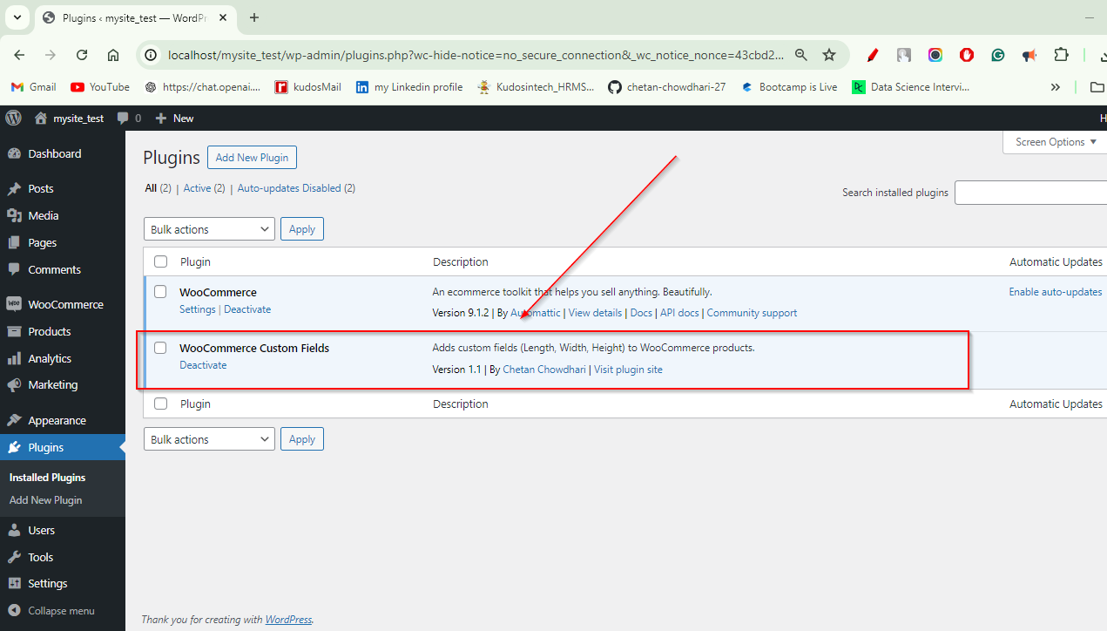

I have activated the plugin on your test site, as shown in the

Screenshot: <https://i.imgur.com/xDQB4Fr.png>

**Testing: -**

I created a test product to demonstrate the plugin's Functionality:

Test Product <http://localhost/mysite_test/product/test-product/>

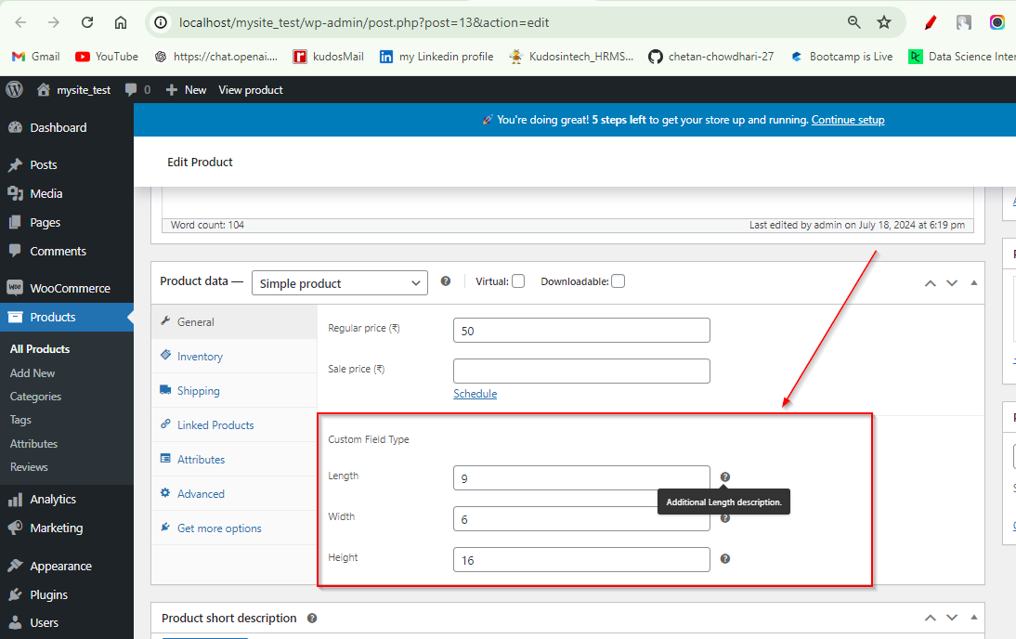

Backend Screenshot:

Frontend Screenshot:



I also tested the plugin using Postman API testing, and it worked as expected.

**Code Comments: -**

I have included comments in the code to explain key parts of the implementation.

